Sweep the Leg, Johnny! hucks the 24 Hours of Laguna Seca for 2003

Well folks, they pulled it off. Despite a last-minute switch to the more demanding 2-person category, Sweep the Leg, Johnny! got down with their bad selves and over 1100 other competitors at this year’s 24 Hours of Laguna Seca mountain bike race. Representin’ the homies were Bonzai (indefatigable LeMans start specialist and eater of hills), Cannonball (curmudgeonly team captain and master of the snot rocket), and JB (critical support specialist and keeper of sanity).

The course was fast and fun, but not nearly as technically challenging as the NorthStar course for the 2002 24 Hours of Tahoe. Many of the single-track sections were windblown trails running along the tops of ridgelines, hard as cement, and fast, fast, fast! Even the rutted washboard fireroad sections were blistering fast, with Cannonball hitting a top speed of 40 mph on several laps. There was some nice, winding, technical downhill single track that started out decent, but quickly deteriorated into massive step-like ruts and sandy, washed-out corners by the third lap. The uphill sections, Hurl Hill and The Grind, were not technical at all, with the Grind being a simple 1.5-mile fireroad climb on which Bonzai had many a fellow competitor for lunch. Race organizers claim the 10.5-mile course included 2000 vertical feet of climbing, but it didn’t seem nearly as tough or painful as the Tahoe course. This is definitely a good entry-level course.

The weather was clear, but a prevailing onshore wind coming in off the very cool Monterey Bay kept temperatures comfortable in the daytime and downright chilly at night. The wind was a major factor in the race too, as several exposed ridgeline sections and the entire Grind faced directly into the wind. This had a noticeable effect on momentum, not to mention the fact that a chilly breeze on a wet jersey when you’re getting ready for your next lap can really suck the life out of your legs. At about midnight though, the wind died down and temperatures and conditions were perfect on in from there.

Mountain bike studs Tinker Juarez and Brian Eutaugh were there throwing down unbelievable solo performances (each over 22 laps), and a five-man team of freakin’ unicyclists kept things real for any of the other competitors who thought there rows were hard to hoe.

From the opening LeMans start, a one-quarter mile run from the starting line to the bike racks, to the first night lap, STLJ! was doin’ Cobra Kai proud, averaging a lap an hour between the noon start time and 10:00 p.m. At that time, deciding prudence was the better part of valor, the tired lads took a 2-hour respite, intending to hit the trail hard and heavy again at 12:00 a.m. One thing led to another and it was after 1:00 a.m. before Cannonball could get his sorry ass back into the saddle and out on the trail.

Equipment, training, and experience made the night rides a real treat this year. With plenty of light from their new light sets and a full moon, Bonzai and Cannonball ripped through the night rides, with both Johnnies riding the Grind without lights at least once. From many of the ridgelines, the beautiful lights of Salinas were visible on the horizon.

As morning dawned, Captain Cannonball decided on his way up the Grind for the team’s 15th lap that the prerace goal of 16 would easily be met and that the team should take the rest of the race to enjoy the atmosphere. Coming into camp, Cannonball decided to have Bonzai wait until the last hour of the race before riding the final lap. Thus, the team finished with 16 laps, experienced the pain, suffering, exaltation, and yes, somewhere around 2 to 4 a.m., the euphoria of pushing the limits, of night riding, of nature, of a finely tuned machine, of life. Damn, it was sweet!

Tables Sweep.1 and Sweep.2 provide race results for Sweep the Leg, Johnny! on the following page. For more information about the 2003 24 Hours of Laguna Seca, go to http://www.24hoursofadrenaline.com/.

Table Sweep.1 provides results for the 2-Person class.

Table Sweep.1 Results for the 2-person category
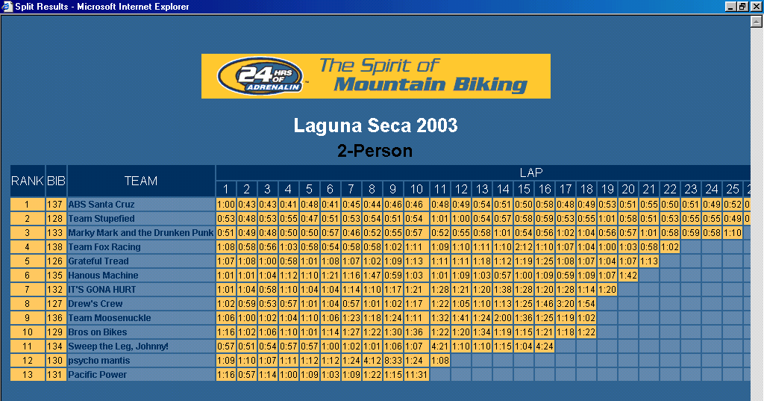

Table Sweep.2 drills down another layer in the Sweep the Leg, Johnny performance at the 24 Hours of Laguna Seca.

Table Sweep.2 Breakdown of STLJ! laps by rider
Lap | Rider | Time | Notes
1 | Bonzai | 57:00 | Lap time includes LeMans start and prologue lap
2 | Cannonball | 51:00
3 | Bonzai | 54:00
4 | Cannonball | 57:00
5 | Bonzai | 57:00
6 | Cannonball | 1:00:00
7 | Bonzai | 1:02:00
8 | Cannonball | 1:01:00 | Night lap
9 | Bonzai | 1:06:00 | Night lap
10 | Cannonball | 1:07:00 | Night lap
11 | Cannonball | ~1:05:00 | Actual lap 4:21:00 including 3-hour break; night lap
12 | Bonzai | 1:10:00 | Night lap
13 | Cannonball | 1:10:00 | Night lap
14 | Bonzai | 1:15:00 | Night lap
15 | Cannonball | 1:04:00
16 | Bonzai | ~58:00 | Actual lap 4:24:00 including 3-hour break

